CHILD SAFE STANDARD 2: A Child Safety policy or a Statement of Commitment to Child Safety

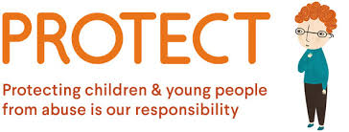
Child Safe Standard 2 (Standard 2) requires schools to develop and publicly communicate a Statement of Commitment to child safety or a school Child Safe policy. Everyone in society has a moral responsibility to keep children safe and to protect them from harm. A Statement of Commitment to child safety helps raise awareness about the importance of child safety in the school and the community and affirms our commitment to child safety and expectations.

Hesket Primary School’s Child Safe policy is an overarching document that provides key elements of an organisation’s approach for child safe environments. It describes the values and principles that will guide us in developing procedures to create and maintain a child safe school environment, and protect children from child abuse.

You can view Hesket Primary School’s Child Safe policy at http://www.hesketps.vic.edu.au and click the ‘Child Safe’ tab.

At our next School Council Meeting, we will reviewing our school’s Child Safe Standard 3: Child Safety Code of Conduct, that once ratified will be required to be signed by all staff, councillors and volunteers will be required to read and sign.

